Localization Principle behind UWB Scheme

1. Basic principle of UWB ranging

(1) TOF (Time-of-Flight ranging method): ranging method belongs to the two-way ranging technology, it mainly uses the signal in two asynchronous transceivers between the Flight Time to measure the distance between nodes. Because in the line-of-sight environment, the TOF ranging method shows a linear relationship with distance, so the result will be more accurate. We denote the time difference between the packets sent and received by the sender as , and the time difference between the packets received and sent by the receiver as . Consequently, the one-way flight time of a packet in the air can be calculated as:

Sender

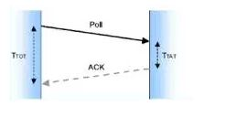

Receiver

But pure TOF algorithm has a relatively strict constraint: the sending and the receiving devices must be running clocks at identical frequencies.

(2) TW-TOF (Two-way Time-of-Flight Method):

a) SS-TWR (Single-sided Two-way Ranging) is a simple measure of the time of a single round-trip message. Device A actively sends data to Device B, and Device B returns data in response to Device A.

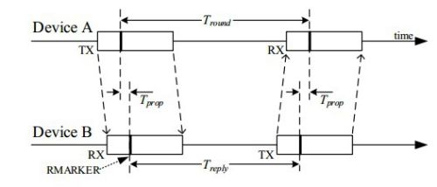

Ranging process: Device A actively sends (TX) data and records the sending time-stamp. After receiving the data, Device B records the receiving time-stamp. After the delay, Device B sends the data and records the sending time-stamp, while Device A receives the data and records the receiving time-stamp. Based on the two local clocks running at the same frequency , two time differences can be obtained, respectively and of Devices A and B. Finally, the flight time of the wireless signal is obtained as follows:

.

The two difference times and are calculated based on the local clocks. Assuming the clock offsets of Devices A and B are and respectively, the flight time obtained will increase with the increase of . The ranging error equation is as follows:



The smaller the , the more accurate the ranging. In addition, covers not only the receiving and sending time of Device B, but also the loading and sending time of data. (In addition to supporting location, UWB can also transmit data: 128 bytes in the Standard Mode, and 1024 bytes in the Extended Mode.) The typical error relationship is as follows: 1 ns is approximately equal to the 750 px distance error.

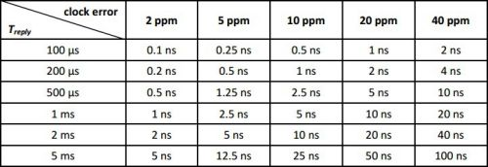

It can be seen that with the increase of and clock offset, the error in the estimation of flight time will be increased, resulting in inaccurate ranging. Therefore, unilateral two-way ranging (SS-TWR) is not commonly used. It can be used for certain applications, when the demand on accuracy is low but that on a shorter ranging time is high.

b) DS-TWR(Double-sided Two-way Ranging）

Double-sided two-way Ranging is an extended ranging technique that records Two round-trip time-stamps to get the flight time. This increases the response time but reduces the ranging error. Bilateral and two-way ranging can be divided into two methods according to the number of messages sent:

1. 4 Messages
2. 3 Messages

4 Messages: Device A initiates the first ranging message and Device B responses, generating 2 time-stamps and ; then after some time, Device B initiates the ranging and Device A responds, generating two more time stamps and .

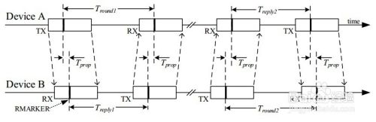

3 Messages: Compared with the 4 message mode, the initiation of the second ranging is avoided. When the Device A receives the data, it will immediately return the data, and finally the following four time differences can be obtained: , , , .

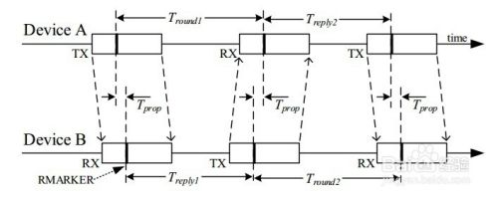

The calculation method of flight time for bilateral and two-way ranging, whether it is 4-message mode or 3-message mode, can be calculated by the following formula:

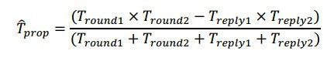

The corresponding flight time error analysis:

The above ranging mechanisms are asymmetric ranging methods, because they do not have to be the same for response time. Even with a 20 ppm crystal, the clock error is in the Picosecond level. The error formula is as follows:

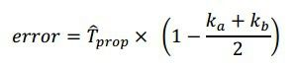

Device A runs at the required frequency , and Device B runs at the required frequency . Both and are close to the value 1.

To figure out the value of the error, if Devices A and B are running with poor crystal oscillation (20 ppm error), for example, Device A is 20-ppm slower, Device B is 20 ppm faster, or put over, this will result in a total error of 40 ppm, so and may be 0.99998 or 1.00002.

Even if the UWB operates over a large range, say 100 m, the air flight time of the wireless signal is about 333ns, because the error is: 20 x 10E-6 x 333 x 10E-9 = 6.7 x 10E-12 = 6.7ps, which is only 2.2 mm after the range is converted.

Note that the response times do not have to be equal, and that the does not have to be equal to the , which provides a lot of convenience for MCU system processing.

The main source of error must be whether the timestamp of the received data is correct. Not the PPM of the crystal.

DS-TWR (symmetrical response time) :

A special example is that the response time of bilateral and two-way ranging method is symmetrical, that is, and are equal. The calculation method of flight time is as follows:

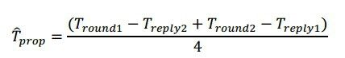

This method just takes a few time-stamps to add and subtract, and then divides by 4 to get the flight time, but it may take more time. The other difficulty with this method is how to ensure that and are equal.

1. UWB positioning principle

The more mature positioning algorithms are: TOA (time of arrival), TDOA (time difference of arrival), AOA (Angle of arrival or called DOA estimation) positioning technology and the mixture of these three technologies.

TOA locates the signal by measuring the travel time of the signal between the mobile terminal and three or more stationary (?) base stations. It uses circumferential positioning.

If the linear distance ruler Ri from the mobile terminal to the base station I is known, then according to the geometric principle, the position of the mobile terminal must be on the circumference with the position of the base station I as the center of the circle and Ri as the radius. That is, if the position of the mobile terminal (X0, Y0) and the position of the base station (Xi, Yi), they satisfy the following relation:

[](http://file.elecfans.com/web1/M00/44/61/o4YBAFpYUuSATbyFAAAkGCvtjog920.png)

The following figure vividly illustrates the principle of TOA algorithm:

[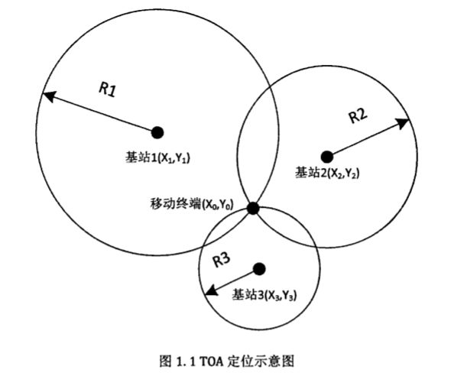](http://file.elecfans.com/web1/M00/44/61/o4YBAFpYUuSAflP2AABNdy7bS-E295.png)

TOA positioning is sensitive to the errors generated in the propagation, which are caused by the interference such as reflection, multipath propagation, non-line-of-sight propagation and noise in the propagation, which may cause the circles to be unable to intersect or the intersection is not a point but a region. At the same time, TOA positioning requires accurate synchronization between the mobile terminal and the base station in time, and the synchronization error of 1ns will bring about 0.3 meters of uncertainty to positioning. Nanosecond synchronization accuracy is not available in many communication systems. Therefore, pure TOA positioning is rarely used in practice.

For this reason, TDOA has improved TOA technology. TDOA positioning does not need to synchronize between base stations and mobile terminals, but only between base stations. Because base stations are fixed, it is much easier to synchronize between base stations than between base stations and mobile terminals. This makes TDOA positioning much easier to implement than TOA positioning, so TDOA positioning is widely used.

It can locate by measuring the transmission delay difference between two different base stations and mobile terminals. Assuming that the distance difference between the position of the mobile terminal and base stations 1 and 2 is R21=R2-R1, then the position of the mobile terminal must be on the hyperbola with the two base stations as the focus and the distance difference between the two focal points is constant R21. That is, if the position of the mobile terminal is (X0,Y0), the position of base station 1 is (X1,Y1), and the position of base station 2 is (X2,Y2), then they satisfy the relation:

[UWB定位技术是什么？UWB定位技术的工作原理详解](http://file.elecfans.com/web1/M00/44/63/pIYBAFpYUziASwhfAABHdW-XHtQ243.png)

Then another set of hyperbolas can be obtained through the TDOA of another set of mobile terminals and base station 1 base station 3 or base station 2 base station 3. The two sets of hyperbolas will produce at most two intersection points, and then the location of the mobile terminals can be determined according to prior knowledge (such as radius range, etc.).

Its basic principle can be well illustrated by the following picture:

[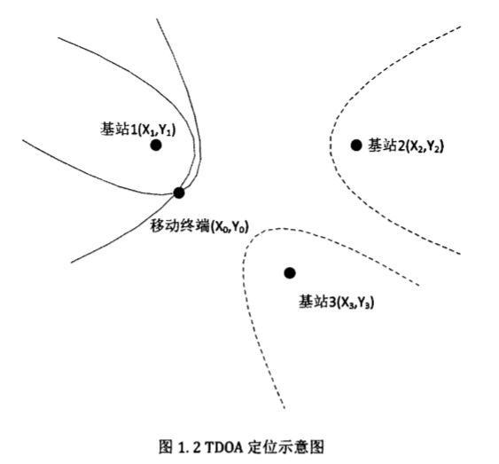](http://file.elecfans.com/web1/M00/44/63/pIYBAFpYUzmAMKFTAAA5Qebs5KY471.png)

AOA estimation is also called DOA(Direction of Arrival) estimation or DF(Direction Finding).

The advantage of AOA is that it requires fewer base stations, and only two base stations can be used for positioning. Before the LTE system, AOA positioning was not paid much attention because the former base station did not have antenna array and the base station was replaced only for positioning, which not only required huge investment but also destroyed the structure and working mode of the original system, making the communication system unable to work normally. With the application of OFDM and multi-antenna array technology in LTE system, AOA localization based on LTE has become a research hotspot. The disadvantage of AOA is that when the distance between the mobile terminal and the base station is relatively long, even if there is a small error of positioning Angle, it will cause a large deviation of positioning distance. Therefore, AOA positioning is more common in medium and short distance positioning.

The following diagram illustrates the basic principles of AOA well:

[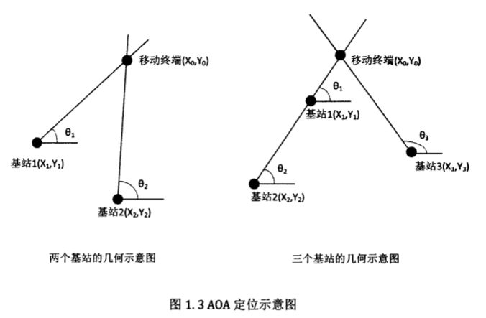](http://file.elecfans.com/web1/M00/44/61/o4YBAFpYUuWANrp3AABHs8nX6gc002.png)

Hybrid positioning technology refers to the mixed use of two or three of the above positioning technologies, such as TOA-TDOA, TOA-AOA, TDOA-AOA, etc., to detect and extract relevant positioning parameters for positioning calculation. Hybrid positioning technology can use a variety of positioning parameters to achieve positioning, comprehensive characteristics of different positioning technology, in the characteristics of each positioning technology to learn from each other, so that the final positioning performance is optimized.

For TOA-AOA based technology, also known as rounded corner positioning, using this method can be achieved by using a single base station for positioning. Firstly, the distance R between the mobile terminal and the base station can be calculated by using the value of TOA, so that the location of the terminal can be determined on the circumference of the circle with the base station as the center of the circle and the radius R. Then use the antenna array to measure the AOA from the mobile terminal to the base station, and make a ray. Then the intersection point between the ray and the circle is the location of the mobile terminal. If the position of the mobile terminal is (X0, Y0) and the position of the base station is (X, Y), the arrival Angle of the signal emitted by the mobile terminal measured in the base station is θ, and the distance between the base station and the mobile terminal is R, then they satisfy the following equation:

[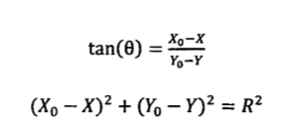](http://file.elecfans.com/web1/M00/44/61/o4YBAFpYUuWARG_4AAAt0g2rXUI561.png)

We can vividly understand the positioning process through the following figure:

[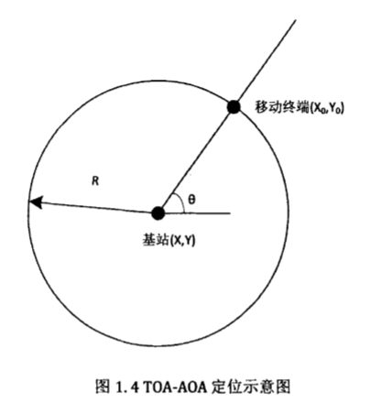](http://file.elecfans.com/web1/M00/44/63/pIYBAFpYUzmADJbfAACS_KEFAjI796.png)

For TDOA-AOA positioning, its positioning principle can be understood through the image below:

[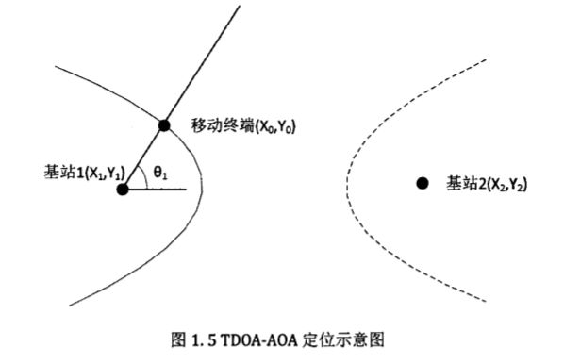](http://file.elecfans.com/web1/M00/44/63/pIYBAFpYUzqAbcwLAAAvQbfcITs085.png)

Wondering what localization scheme you would recommend for implementation?

I would recommend TDOA, for its better performance in accuracy. At the same time, TDOA is easier to implement. Combination of multiple schemes can also be considered.